Geometry: Unit 1, Lesson 1
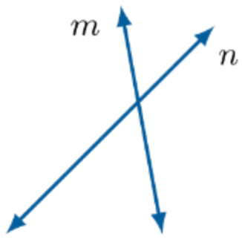
- Are the two given lines an example of parallel lines?

No

- What is the definition of parallel lines?

Two lines that do not intersect

- A set of lines is shown. The image represents three lines that are what to one another.
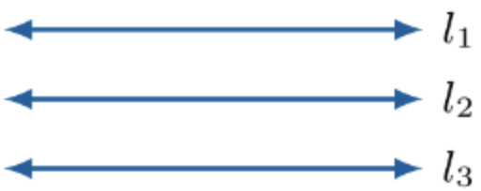

Parallel

